# Math Question Generation - New Set

## Question 1

@title Drawing Marbles from a Bag  
@description Calculating probability of drawing certain colored marbles.  
  
@question A bag contains 5 red marbles, 7 blue marbles, and 8 green marbles. If one marble is chosen at random, what is the probability that it is either red or green? Give your answer as a simplified fraction.  
  
(A) $\frac{5}{20}$  
(B) $\frac{13}{20}$  
(C) $\frac{7}{20}$  
(D) $\frac{8}{20}$  
(E) $\frac{12}{20}$  
  
@instruction Choose the correct probability.  
@difficulty easy  
@Order 1  
  
@option $\frac{5}{20}$  
@@option $\frac{13}{20}$  
@option $\frac{7}{20}$  
@option $\frac{8}{20}$  
@option $\frac{12}{20}$  
  
@explanation There are $5 + 7 + 8 = 20$ marbles in total. The number of favorable outcomes for red or green is $5 + 8 = 13$. Thus, the probability is $\frac{13}{20}$.  
@subject Quantitative Math  
@unit Data Analysis & Probability  
@topic Probability (Basic, Compound Events)  
  
@plusmarks 1

## Question 2

@title Area of a Composite Garden  
@description Finding the area of a shape made from a rectangle and a semicircle.  
  
@question A garden is shaped like a rectangle of length 12 m and width 8 m, with a semicircle of diameter 8 m attached to one of its shorter sides (as shown in the diagram below). What is the total area of the garden? (Use $\pi \approx 3.14$)  
  
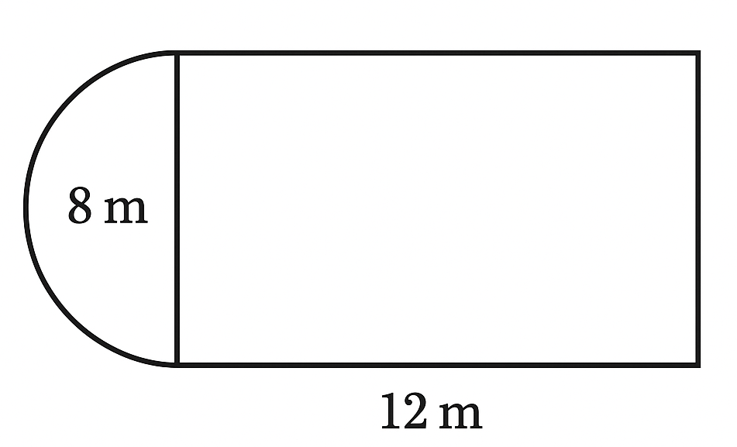  
  
(A) $96 + 25.12$ m²  
(B) $96 + 50.24$ m²  
(C) $90 + 25.12$ m²  
(D) $100 + 50.24$ m²  
(E) $96 + 100.48$ m²  
  
@instruction Choose the correct total area.  
@difficulty moderate  
@Order 2  
  
@option $96 + 25.12$ m²  
@@option $96 + 25.12$ m²  
@option $90 + 25.12$ m²  
@option $100 + 50.24$ m²  
@option $96 + 100.48$ m²  
  
@explanation Area of rectangle = $12 \times 8 = 96$ m². Radius of semicircle = $\frac{8}{2} = 4$ m. Area of semicircle = $\frac{1}{2} \pi r^2 = 0.5 \times 3.14 \times 16 = 25.12$ m². Total = $96 + 25.12 = 121.12$ m².  
@subject Quantitative Math  
@unit Geometry and Measurement  
@topic Area & Volume  
  
@plusmarks 1